Restorable Wetlands Assessment
(Michigan and Ohio)

Project: Through a comprehensive assessment of spatial and biological data we will evaluate the restorability of the Western Lake Erie coastal landscape to:
- Identify priority areas for the restoration of coastal wetlands to preserve the ecosystem services that benefit wildlife and people.

Link to overarching WLEB strategies:
- Implement innovative and resilient on-the-ground habitat restoration projects
- Integrate ecological and human well-being values to create a shared vision, engaging a broad spectrum of public and private interests
- Direct restoration investments and inform management decisions

The restorable wetland assessment boundary is shown in black. Green-shaded areas represent places where coastal wetland restoration has the best chance of success.
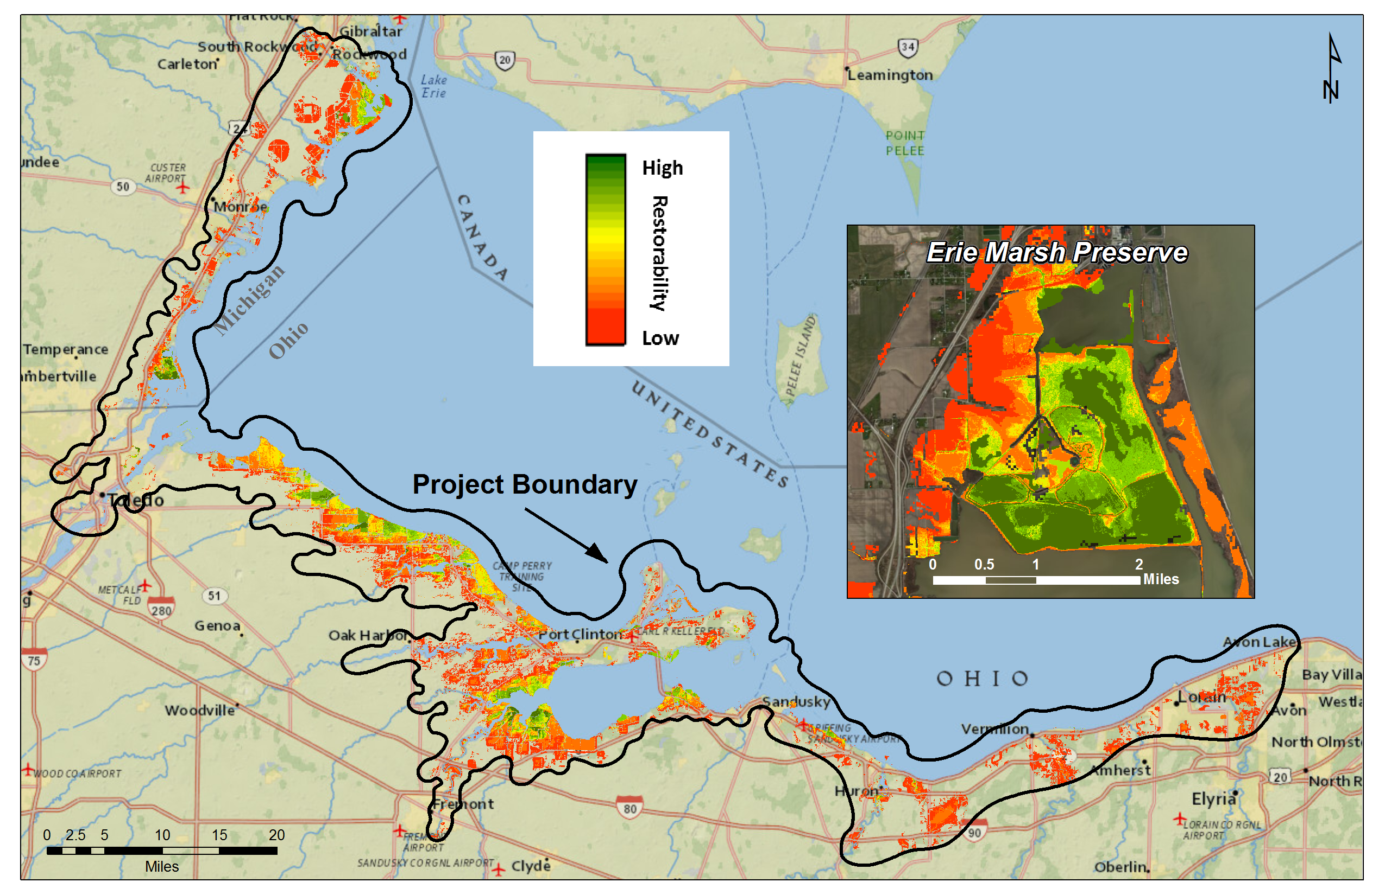
Project summary:
While extensive and species-rich wetlands continue to provide key ecosystem services that people rely on (e.g., fish and bird habitat, water quality improvement), the marshes, wetlands, and shorelines of Western Lake Erie have been vastly altered or lost entirely due to development, conversion, drainage, altered hydrology, and modified sedimentation patterns over time (see figures above). Only 5% of the original 307,000 acres of Lake Erie wetlands remains; these losses continue. In the 2012 Lake Erie Biodiversity Conservation Strategy, the product of a comprehensive two-year study of specific strategies and actions to protect Lake Erie biodiversity, the remaining coastal wetlands were assessed as “fair” – meaning that they will not be viable without conservation action. Thoughtful restoration that considers habitat function as well as current and future threats is critically needed to ensure that the remaining biota can persist and be resilient over time. We have a tremendous amount of ecological and geologic data describing the Western Lake Erie Basin. Through a comprehensive assessment of this data, we will arrive at a restorability index to guide and inform our conservation investments.

Key partners:
- National Oceanic and Atmospheric Administration
- U.S. Geological Survey
- University of Michigan-Dearborn

Project timeframe: Results anticipated October 2013

